**Real-time Face Feature Extraction and Feature Match for StateFarm Consumer Personalization**

To Peer

Based on the personalization of commerce marketing, th**e** purpose of this project is (1) to establish a novel algorithm of extracting the real-time face features, and (2) based on face features, to match the existing database information so as to lock their demographic information and active information that can be used for the consumer personalization.Figure 1 displays the holistic project framework, where the HOG and Regression Tree was used to extract facial key points, and thenSVM to accomplish the emotional classification and Res Net algorithm to gain face features, and finally the face features were match against the cloud database to extract the known the consumer information. The project was developed to be suitable to various control accesses, such as database expansion, mobile app, PC, and social media. Based on the information, the businesses can develop the personalization strategies to enhance consumer experience and service quality.

To a 5-year child

Do you feel embarrassment if you want to play with your friend but hard to start the conversation since you don’t know or forget his/her name?

We develop an interesting emotion analysis and face recognition app. This fun app can help you and your friend to recognize and understanding each other. Our system is equipped with a smart glass and a cloud analysis system. This camera equipped glass can help you to know your classmate name, age, current emotion. It also provides a friendly smartphone interface that connects to your smart-glass. It can be further developed in future for object recognition (toys information) and even a toy recommendation system that meets you needs.

To a senior engineer with years of experience

Our face recognition and feature analysis system have four parts: Cloud server, mobile APP, desktop APP and OpenSSL encrypt system. The system is designed for several advanced technologies such as Computer Vision, Deep Learning, Big data and safety communication. The human faces are input into our system, and the images are processed by HOG algorithm and random forest classifier to lock the face location. After that, we apply the ResNet model to match the data in our database. Here, the database will supply information according to the ResNet result. All the algorithms can be implemented on GPUs of cloud servers, and the information can be directly exported into the UI.

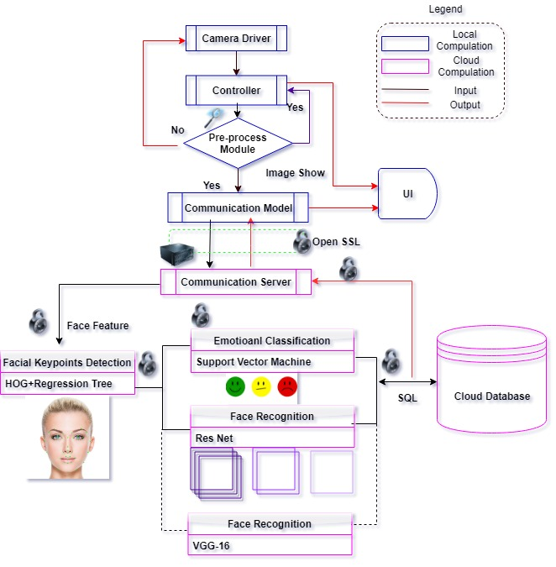

Figure 1. Project Research Framework